**LEBANESE AMERICAN UNIVERSITY**

**USAID – HIGHER EDUCATION SCHOLARSHIP PROGRAM**

**HES - Volunteering Program Verification Form**

This form is to be used to document volunteering hours. If a student volunteers for multiple organizations, a separate form must be used for each organization. **This form must be turned in by the 28th of each month, the latest.**

I certify that the scholar Jawad Younes completed a total of 8 hours of service at Life Sculptor.

The hours were completed hours as per the below:

Hours # 2 (date) _02/09 - 06/09_ (initials of supervisor) __A.K.___

Hours # 2 (date) _09/09 – 13/09_ (initials of supervisor) __A.K.___

Hours # 2 date) _16/09 – 20/09 (initials of supervisor) __A.K.___

Hours # 2 date) _23/09 – 27/09 (initials of supervisor) __A.K.___

Brief description of the activities the scholar performed or participated in:

I have been a part of the Research Team at Life Sculptor I have done the following tasks  
The Impact of Homelessness The presence of mental health disorders among homeless populations:  
What are the common mental health issues in these populations? (PTSD, depression, anxiety, substance abuse…)  
  
The Impact of Family Dynamics Course:   
Peer influence vs. Family influence: How can a teenager’s social circle influence him and his well-being? In what way is it different from family influence?  
  
  
The Types and Impact of Loneliness Course:   
Impacts on mental health:  
Can some disorders be due to loneliness?   
  
Does loneliness have any effects on one’s self-esteem and self-worth?   
  
  
Does it have an impact on emotional regulation?

Written feedback about the scholar’s performance:

Jawad has made great contributions to Life Sculptor. His work is exceptional and he submit his tasks on time

Please rate the overall performance of the scholar at your organization:

|  |  |  |  |
| --- | --- | --- | --- |
|  | Mastery (5) | Proficient (3) | Emerging (1) |
| **Problem solver** | X |  |  |
| **Engaged & Committed** | X |  |  |
| **Open-minded & multicultural** | X |  |  |

Signature

& stamp

__________________________

_

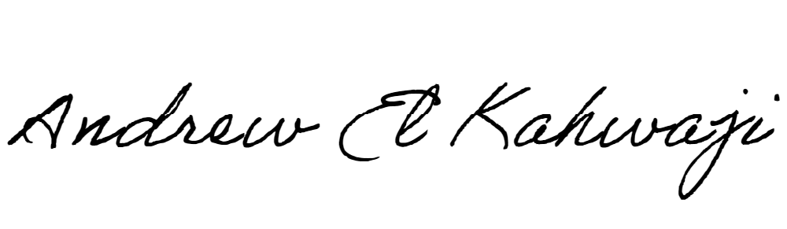

Printed Name _Andrew El Kahwaji_

Date __25/09/2024___

Email __andrew.lifesculptor.coo@gmail.com __

Phone __+961 71 914 378__

**LEBANESE AMERICAN UNIVERSITY**

**USAID – HIGHER EDUCATION SCHOLARSHIP PROGRAM**

